Report

Thematic Workshop 2

**Table of Contents**

Practical Information **3**

Attendants 3

Agenda 3

**Introduction** **4**

**OSLO (Open Standards for Linked Organizations** **4**

GreenMov 4

Flemish track OSLO Hoppinpunten 4

Context Passenger Transport Hubs 4

Objective and Approach **6**

Objective 6

Approach 6

**Overview of the adjustments to the model** **7**

**Next Steps** **9**

**Annexes** **10**

Passenger Transport Hubs Model 10

# Practical Information

* Date: 23/06/2022
* Location: Virtual

## Attendants

Agentschap Wegen en Verkeer

* Joris Cornu

Digitaal Vlaanderen

* Geert Thijs
* Tom Callens
* Alexis Driesen
* Arne Scheldeman

Inter

* Marcel Wijnker

UGent-IMEC

* Brecht Van de Vyvere

## Agenda

|  |  |
| --- | --- |
| **Timetable** | **Topic** |
| **09:00 - 09:10 AM** | **Welcome and introduction** |
| **09:10 - 09:20 AM** | **Recap of last workshop** |
| **09:20 - 09:50 AM** | **Passenger Transport Hubs model** |
| ***9:50 - 10:00 AM*** | ***Break*** |
| **10:00 - 10:15 AM** | **Publication PURL.eu** |
| **10:15 - 10:25 AM** | **Registering issues** |
| **10:25 - 10:45 AM** | **Q&A and next steps** |

# Introduction

## OSLO (Open Standards for Linked Organizations

The initiative for this standardization project originates from a collaboration between Digital Flanders and GreenMov. The intention is to ensure more coherence and better understandability and retrievability of the data. A semantic standard facilitates sharing and exchanging data between different stakeholders. Each data subject can directly use and interpret the data of the other. This stimulates the exchange and reuse of data and reduces the cost of exchange. The semantic standard provides machine-readable data. It also brings efficiency gains if the data can be used in different processes. OSLO makes a concrete contribution to semantic and technical interoperability. The vocabularies and application profiles are developed in co-creation with, among others, international administrations and authorities, federal partners, academics, the European Commission and private partners.

## GreenMov

[GreenMov](https://green-mov.eu/) is a CEF (Connecting Europe Facility) project within the framework of the Green Deal to bring smart mobility data together and make it accessible with the ultimate aim of realizing greener mobility. GreenMov and Digital Flanders contribute to harmonizing mobility datasets, creating integrated services (cross-services) and new cross-border functionalities by combining various datasets.

## Flemish track OSLO Hoppinpunten

In Flanders Passenger Transport Hubs are being branded as “[Hoppin Points](https://www.werkenaandering.be/en/working-on/hoppin-points)”. A semantic data model of Passenger Transport Hubs is created, in Dutch, and currently in public review. The [OSLO Hoppin points](https://data.vlaanderen.be/standaarden/kandidaat-standaard/vocabularia-en-applicatieprofielen-hoppinpunten.html) core vocabulary and application profile can be retrieved from ["Standard register Hoppin points"](https://data.vlaanderen.be/standaarden/kandidaat-standaard/vocabularia-en-applicatieprofielen-hoppinpunten.html). This is used as a basis for the OSLO - Passenger Transport Hubs track. The model is translated in English and extended to the European requirements.

## Context Passenger Transport Hubs

The Passenger Transport Hub is based on the “Hoppinpoints” track, described above. In general, a Passenger Transport Hub is a place with a diverse range of transport options. Depending on the location, you will find trains, tram and bus stops, shared vehicles, a Park & Ride, bicycle parking spaces, etc. These modes of transport are coordinated with each other and are preferably supplemented with additional services. The aim is to facilitate multimodality. A Hoppinpoint is a Passenger Transport Hub that meets specific criteria and it is divided into four major parts. These are:

* **Infrastructure elements**: These elements represent the physical aspect of the Passenger Transport Hubs. For example: information points, parking facilities, bicycle sheds…
* **Transportobjects**: These objects represent the transport nodes and their connections within the available transport networks.
* **Mobility services**: These are the available mobility services at the Passenger Transport Hubs. For example: mobility by train, bus, taxi, shared cars, bikes…
* **Additional services**: These are the additional services available to the traveler, making his/her trip as efficient as possible. For example: mailboxes, bakeries, sanitation facilities, bike repair shops…

The model can be retrieved in the Annex (See 6.1).

# Objective and Approach

This section clarifies the purpose and approach of the second thematic working group.

## Objective

1. Giving a summary of the fist thematic workshop in order that everyone remembers what the key points were.
2. Presentation of the adjusted model. We wanted to discuss the model in its entirety to see if there were still some comments or uncertainties, but with a main focus on the adjustments we did.
3. Giving a tour on how to consult the model, the application profile and the vocabulary on PURL.eu, where it is published at the moment and explaining what all the different parts mean. As well as, showing how to raise issues about the model on GitHub.
4. Give information about the next steps that will be taken.

## Approach

During the second thematic workshop, a presentation briefly summarized what had been presented in the previous business workshop. Subsequently, we dived deeper into the model. We showed the model in its entirety in MURAL, by which the attendants could raise questions and uncertainties. During this part, we also explained the new adjustments in the model. Afterwards, we guided the attendants to PURL.eu, where the application profile, the vocabulary and the model are published. We showed them how to reach and use these pages, and also how to raise issues if needed.

# Overview of the adjustments to the model

One additional class has been added to the model, called ResourceReport. We added this class on demand, because this positively affects the implementation of the model.

The goal of ResourceReport is to generate a summary number based on different criteria. The decision to add this class is made, based on the ‘size’ of possible use cases in real life. For example, if it is needed to generate a number for the amount of rental bikes at a train station of a capital city or the amount of available parking spots in a big city, this would otherwise generate a huge array of different resources. With the class ResourceReport one number will satisfy the needs.

The cardinality of all the attributes, except the summary number, is zero to many. This cardinality is chosen because different filters/criteria could be added to generate a report. For example, the amount of available bikes with different actuator types (these can be electrical bikes, normal bikes, etc) at all possible locations near the train station.

The class consists of seven attributes. Firstly, actuator embraces the different propulsion types available like electrical, hybrid, non-electrical. The location is very broad. This can be any location where there is a service available, for example the station of Leuven. The means of transport consists of the different modes of transport that you can use like public transport, bicycles, steps, etc. The number returns the amount of resources available. For example, there are five bicycles available at the bike station at station Brussels-Central. The service represents the mobility service. The status, in general, is about whether a resource is available or unavailable. Lastly, the type returns the type of resource you are looking for. This can be, for example, a seating place, bicycles, bicycle pumps, etc.

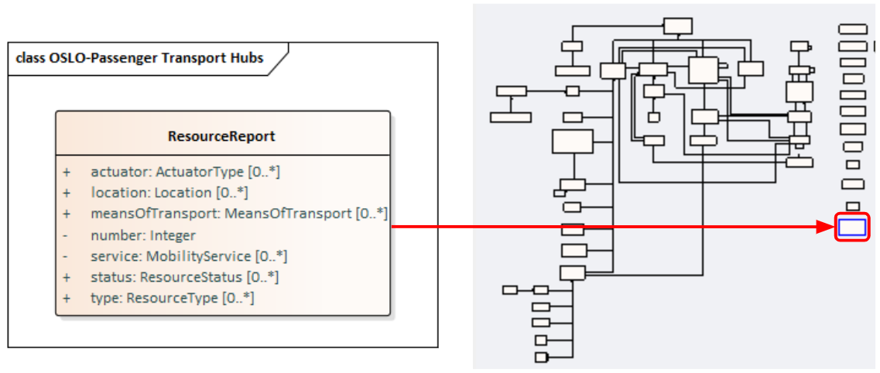

1. **Publication PURL.eu**

Recently, the model, together with the application profile and the vocabulary, was published on PURL.eu. This can be found by going to PURL.eu and selecting 'Passenger Transport Hubs' in either 'Application Profile' or 'Vocabulary'. Here the model and all classes with their attributes can be consulted at any time. For each class and attribute you will find a definition and sometimes also a usage note. If you click on the object, you will be directed via a URI to the vocabulary, where this specific object is explained.

The publication of the OSLO-PassengerTransportHubs model can be found by clicking on the following links:

* Application profile: [Link](https://purl.eu/doc/applicationprofile/mobility/passenger-transport-hubs/)
* Vocabulary: [Link](https://purl.eu/ns/mobility/passenger-transport-hubs/)

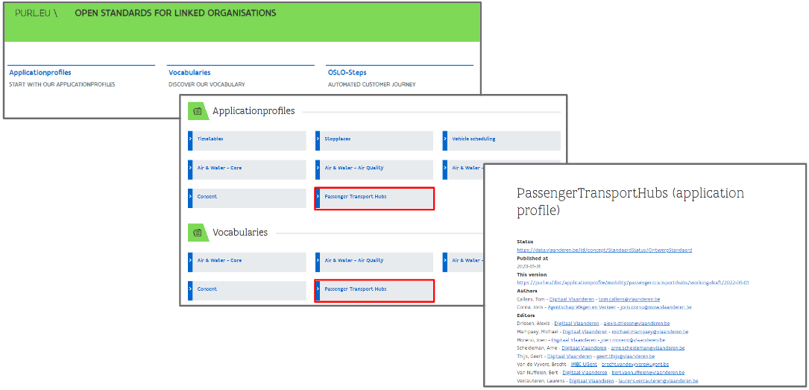

Adjustments will be made in the two upcoming weeks until the public review is communicated in the beginning of July.

If you have any comments on any aspects of the model (e.g. cardinalities, definitions, links, typo's...) already or during public review, these can be communicated via:

* GitHub: [Link](https://github.com/Informatievlaanderen/OSLOthema-passengerTransportHubs)
* Mail: [arne.scheldeman@vlaanderen.](mailto:arne.scheldeman@pwc.com)be of [alexis.driesen@](mailto:alexis.driesen@pwc.com)vlaanderen.be

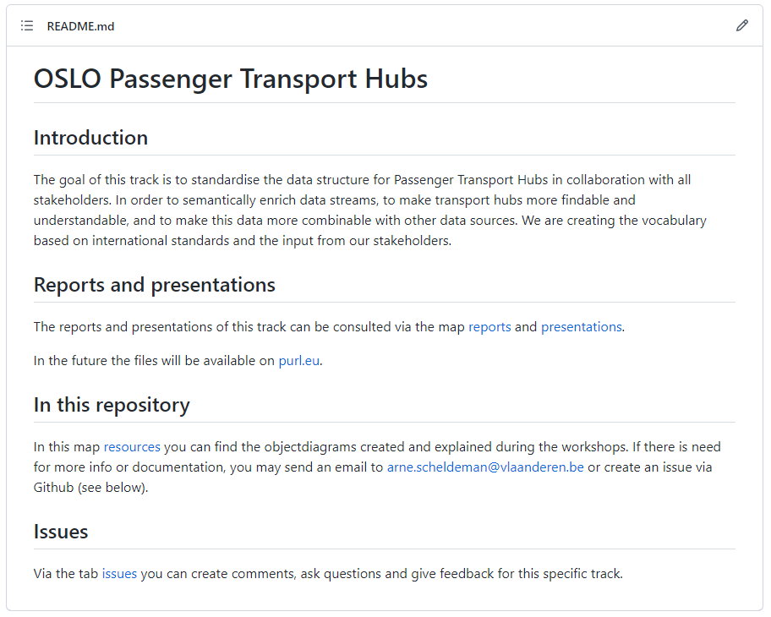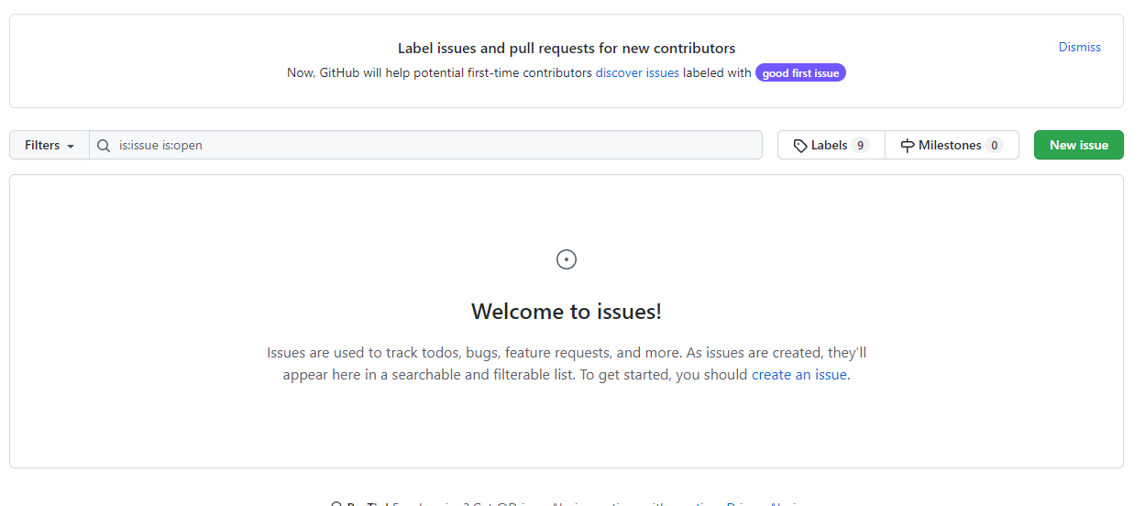

# Next Steps

The Passenger Transport Hubs Model will go in **public review** in approximately two weeks. In the period leading up to the public review, the input from this working group will be processed. The model published at PURL.eu will be finalised. Issues that were raised during the workshop, or that will be raised before the model goes in public review, will be fixed. Lastly, we will validate if it is possible to put an overview page on the standards register at “[data vlaanderen](https://data.vlaanderen.be/)”.

If you have seen an issue, feel free to share them via [GitHub](https://github.com/Informatievlaanderen/OSLOthema-passengerTransportHubs) or send a mail directly to [arne.scheldeman@vlaanderen.be](mailto:arne.scheldeman@vlaanderen.be). We will do our best to solve them as soon as possible.

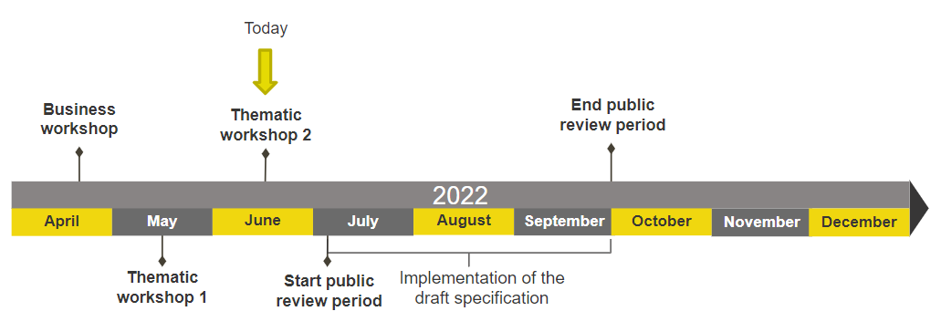

# Annexes

## Passenger Transport Hubs Model

